
Using information technologies for a better and more independent future

news and views, volume 4. Spring 2011

Exploring and designing together
Last summer SUS-IT researchers conducted a two-day creative workshop at the Riverside Café in Guildford, Surrey. The workshop was themed “Family History and Memories” and 16 retirees participated in it. During the workshop the subject of identity and the experience of documenting and communicating personal life history to family and friends was discussed. Three new conceptual devices that depicted various ways of documenting and sharing family history and memory were then demonstrated to the participants (see picture below).
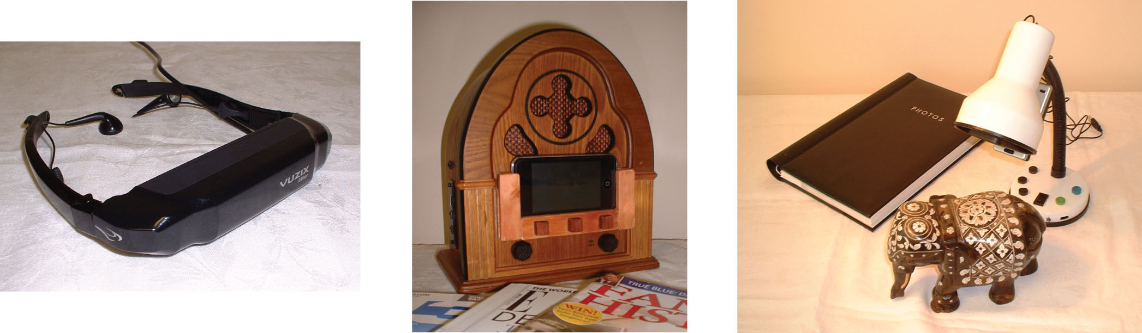
(Left to right) Travel glasses allow you to travel and immerse yourself in a place that you have been to in the present or the past. These places can be represented through photo archives or virtual reality. The Reminiscence radio records your life stories as well as favourite music onto a timeline. You can also invite friends and family to record their stories of you and play them back in your own time. Story lamp is a device that scans and recognises an object or photo with a story behind it. The story, told by you, is recorded while the object is being scanned. Next time when you, friends or family put the same object under the lamp, it recognises the object and automatically plays back the story.

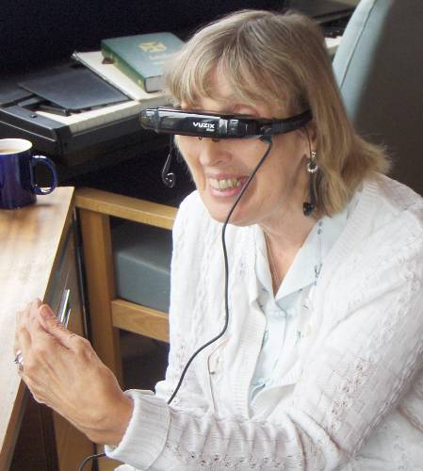
The participants were able to try out the Travel glasses during the workshop and they were asked what they thought of them (picture on the left). Feedback on the Reminiscence radio and Story lamp was also collected from the participants.
After lunch, our participants put on their ‘designer’ hats and became co-designers, working with us to redesign the devices (picture in the middle) into products that would meet their needs and wants. In total, both groups produced 7 new concepts.
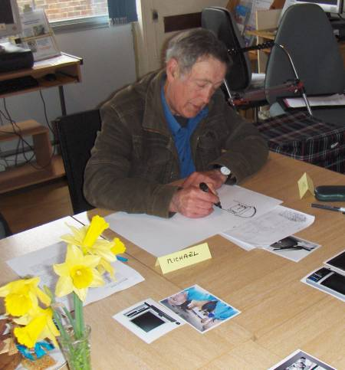
One of the concepts our co-designers came up with (picture below left) was a portable modern version of the Reminiscence radio. The redesign included a larger touch screen with the capability to store photographs and record news broadcast.
All the participants thoroughly enjoyed the workshop. They were able to exercise their creativity in coming up with new ideas that would help them store, share and relive their memories.
Comments from our co-designers after the workshop
“I think in group settings you probably have more ideas coming in, if you have one to one discussing…it will be just ourselves and it will be single track, you wouldn’t get ideas coming from sideways.”
“I wasn’t really interested at all in computers as things but today, I’m quite intrigued about them I must say.”

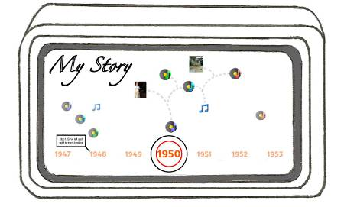

SUS-IT on BBC Today Radio Programme
Rory Cellan-Jones, BBC’s technology correspondent, interviewed SUS-IT colleagues from the University of Surrey as well as three of their creative workshop participants on Radio 4 on 11th March 2011. Professor David Frohlich introduced the SUS-IT project, why we need to engage older people in the design of ICT products and how we did it through the creative workshops. Our 3 participants (see group picture below, front row from left to right; Sonia, John and Margaret) were asked about their attitude towards technology, what they thought of the workshop and their thoughts on the devices. Sonia who doesn’t own a PC (but is learning to use one) was given a fast-track introduction to Twitter, a social networking site, by Rory who featured Sonia in his tweet http://rorycellan.posterous.com/fascinating-project-at-surrey-uni-gets-older and website http://www.bbc.co.uk/blogs/thereporters/rorycellanjones/
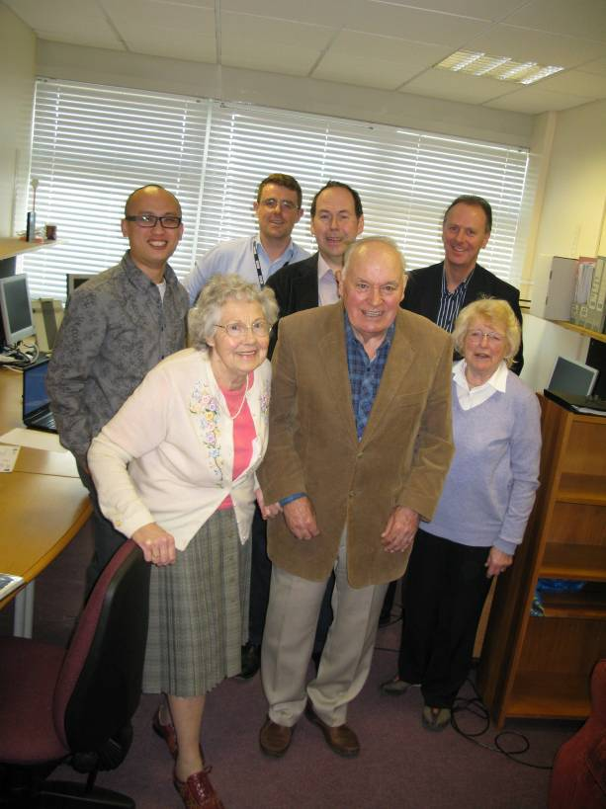
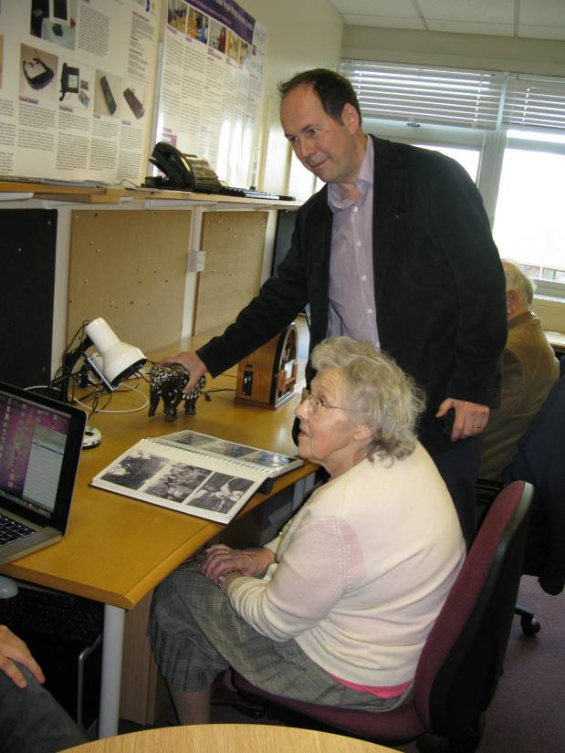

Technology Joke

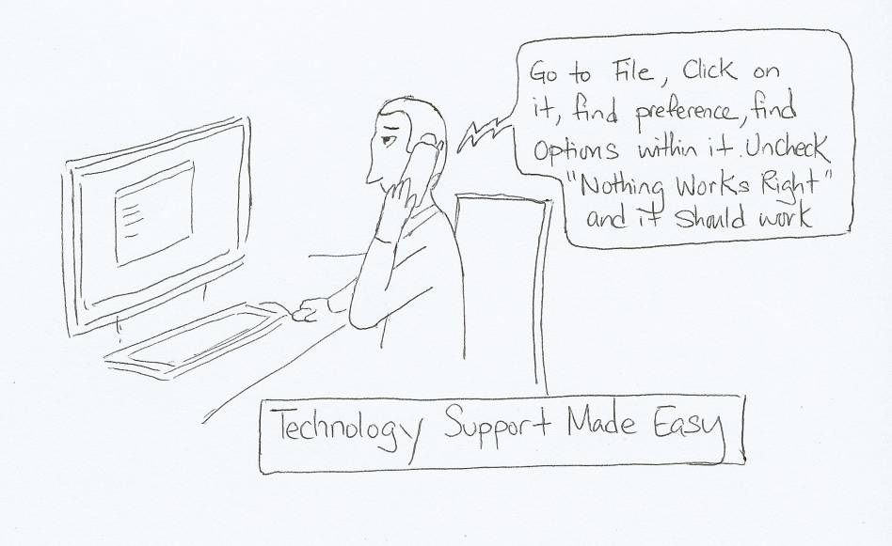

About Sus-IT
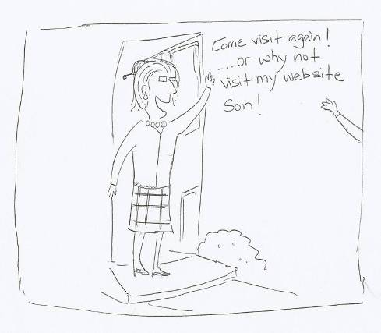
Sus-IT is a research project which is exploring how we can all remain independent, doing the things we want to do, long into our old age, with a little helping hand from new technologies and other people.
In this research we are working closely with people who are currently aged 50 to 90+ to help anticipate how future digital technologies can meet our changing needs. In our surveys we have found some participants who have been using computers for over thirty years, and continue to be excited by the latest opportunities. The majority our participants are relatively new to the whole experience, for example, just taking their first steps through training programmes run by Age UK. We have also included people who are not using computers, to help to test the potential for new systems. It is important that we understand and value the differences between people and their relationship with technology
This edition of the newsletter features a study carried out by Surrey University. We also have studies and surveys taking place around the country, in and around the Universities of Dundee, Lincoln, Loughborough, Middlesex, Nottingham, Northumbria and Anglia Ruskin. Wherever you are, we would like to say a big thank-you for taking part.
For more information about Sus-IT please visit our website: http://www.sus-it.lboro.ac.uk/

Contacts
Sus-IT Principal Investigator  Professor Leela Damodaran  Lead Co-Investigator  Wendy Olphert | Department of Information Science  Loughborough University  Loughborough Leicestershire LE11 3TU  Website: www.sus-it.lboro.ac.uk
Guest editor, photos and cartoons  Chris Lim | Faculty of Arts & Human Sciences  University of Surrey  Guildford GU2 7XH
Newsletter editor  Suzette Keith | Engineering and Information Sciences  Middlesex University  London NW4 4BT  Email: s.keith@mdx.ac.uk  Tel: 020 8411 5098

Acknowledgement
 | The Sus-IT research project (Grant Number RES-353-25-0008) is funded by the ESRC as part of the New Dynamics of Ageing programme

