
Using information technologies for a better and more independent future

news and views, volume 3. Summer 2010

Positive Ageing: Using technology to improve everyday life
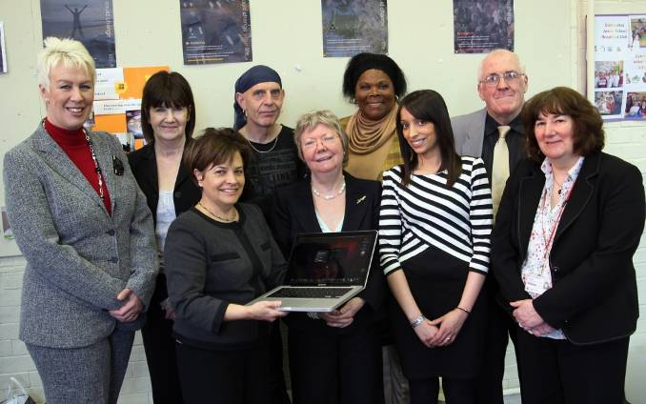
Over 60 people attended a very special event organised at the Enterprise Centre Cotmanhay by Sus-IT researchers as part of the annual Festival of Social Science, in March 2010. It was a chance to publicise online access to local services and the positive impact of using digital technologies. Speakers included local MP Liz Blackman, Irene Hardill (Nottingham Trent University) and a number of local service providers.
In the picture, left to right : Cheryl Pidgeon, Liz Blackman MP, Prof Leela Damodaran (Loughborough), Hugh Ullyat (Research participant), Prof Irene Hardill (Nottingham Trent), Rosalind Matthews (Research participant), Jatinder Sandhu (Nottingham Trent), Mike Stevens (Research participant), Wendy Olphert (Loughborough)

Improving everyday life
At the Festival event some of the Sus-IT research participants shared their success stories such as these ones:
Bally – staying connected and seeing the family
Bally’s children now work away from home, elsewhere in the UK and one son is abroad. She has discovered Skype, and her children have helped her to use it. ‘My daughter lives in Nottingham, my son lives in Bristol and my eldest son is coming and going to Holland all the time. So it is nice for me to use my Skype and I can see them when we talk’. She went on to say, ‘it is free as well!’

Hugh – loving the music
One of Hugh’s hobbies is listening to music and speeches, ‘it is like a diet’ he has a ‘daily intake, I have a hunger’ to hear music and speeches. For a long time he has used a cassette player, and with the cassette tapes he can listen to them,
rewind them, and write down words from the speeches. But his tapes are now wearing out, and he is concerned about trying to preserve and keep them, and he has investigated a new form, a digital MP3 format. He is converting them, and
safeguarding his treasured music and speeches.

Catherine - Don’t be afraid, discover a new world
Catherine was, ‘petrified’ about using a computer, but ‘with a lot of persuasion, principally from my doctor who thought I would enjoy it’, she has bought one. Catherine has made a real effort to overcome her fears, ‘it’s been a slow process.’ She has realised that, ‘I couldn’t really do anything irrevocable on the computer; I could always press the back button’. Catherine has found that a computer can, ‘augment your social life. It’s an easy way to find out what’s going on at the cinema, what’s going on in the city. If you like cookery you can access different recipes - a vast, wider selection than you could just by having individual books. Even dealings with local hospitals or booking appointments – it’s so much easier’.

Community Concern Erewash
Founded in 1992, Community Concern Erewash in based in Cotmanhay, Ilkeston, Derbyshire and supports a wide range of local community projects across the borough of Erewash. See also : http://www.communityconcernerewash.co.uk/index.html

The Annual Festival of Social Science
The event at the Enterprise Centre in Cotmanhay was supported by the Economic and Social Science Research Council (ESRC). These events are organised to give an insight into some of the country's leading social science research and how it influences our social, economic and political lives - both now and in the future. http://www.esrc.ac.uk/ESRCInfoCentre/FSS/

Getting disconnected
A personal experience by Suzanne Lockyer
Although I now fall into the category of ‘older person’, I have grown up with computer technology; in my early twenties I worked at a University Computer Centre – feeding in punched cards and changing magnetic discs, so I really have been in from the beginning! My husband was an IT professional, so we had a PC at home from an early Amstrad with a word processing package on cassette tape! As a traditionally trained typist, word processing seemed like a miracle and I ‘self taught’ through command driven Word Perfect through various versions of Microsoft Word.
I studied Library and Information studies as a mature student, starting in 1987. As an information professional, I naturally progressed into Internet use, but did not realise how dependent I was until I became temporarily disconnected.
In July 2009 I sold my house and moved into a rented apartment. This was a new build, described as having BT and Sky connections; I naively thought this meant phone and broadband connection were near automatic. I was shocked to discover how wrong I was: BT still required over £100 connection fee; the minimum contract was 18 months (my tenancy was 6 months) and there was no way round this; and Sky require a 24 month contract.
I resigned myself to being dependent on my mobile phone, again having a shock when I realised that all the ‘authorities’ I was forced to deal with in the aftermath of moving home used 0845 numbers, which are expensive by mobile. In an effort to be reconnected, I invested in a dongle; this proved useless as I was on the border of the coverage area.
The problems of losing my internet connection were endless:
- I banked online, mainly because I did not have a branch nearby where I lived or worked. I thought I would be able to visit the bank but it seems banks do not offer services, and just point you to a phone! I could not even pay a bill in my own bank;
- I had been used to finding out all sorts of information online e.g. travel routes, weather, information about houses (I was house-hunting);
- I was also job hunting and employers now use online application processes, and all communication is by email or logging onto your application;
- I had bought a new laptop, and this obviously expected access to the internet and was continually demanding updates and security checks!
It is difficult to remember the daily hassles of losing connection. I am fortunate in having a good connection at work, and the ability to check on different suppliers and the motivation to continue my efforts to remain connected. Also my experience was temporary and I knew that it was. However, someone with less motivation, who was only tentatively ‘connected’ would soon give up under these circumstances.
International recognition for Sus-IT
Sus-IT researchers have been travelling the world to talk about our work:
Canada - Prof Leela Damodaran has announced an exciting opportunity for the Sus-IT project team to collaborate with Prof Wendy Young and colleagues at the Memorial University Newfoundland. Prof Young and her team have secured funding from the Canadian Institute of Health Research (CIHR) to collect data about ICT use from a large sample of older people in Labrador and Newfoundland, which we will be able to compare with the data we are collecting in the UK. Leela and Wendy Olphert also headed off to Vancouver, Canada to talk about the Sus-IT programme at the International Society for Gerontechnology Conference. (Gerontechnology research is all about using technology to benefit older people)
Austria and USA – Colin Machin attended the International Conference on Computers Helping People (ICCHP) in Vienna where he talked about the work of his Sus-IT team. Colin presented a paper called “Towards accessible interactions with pervasive interfaces, based on human capabilities”. This is based upon work that his group is doing on providing help to people who struggle with interfaces to computers and other electronic devices and seeks to modify the interface to suit the individual needs of the user. The main theme of the presentation was about bridging of gaps between, on the one hand, the companies that produce the technologies to help people interact with computers and those who develop the software that provides us with services like email and web browsing. Once this has been done, more of the assistance needed will be built into these applications, so everyone will be able to take advantage. A related paper was also presented in Raleigh, Texas, USA.
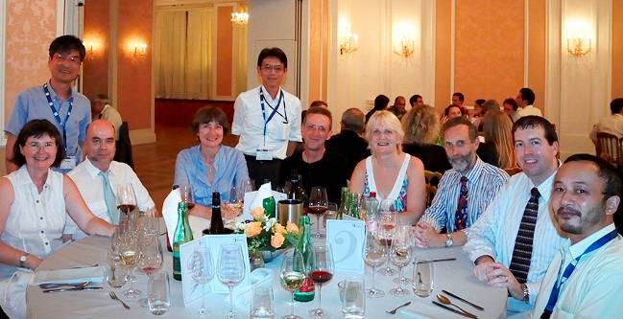
In the picture: Colin (3rd from left) and editor Suzette Keith (4th from left) met up with colleagues from Hungary, Finland, Italy, Denmark, Japan and Korea at the conference dinner in Vienna’s Kursalon, where in 1868 the first concert featuring compositions by Johann Strauss took place.
Netherlands - Veronika van der Wardt was in Delft, Netherlands at the European Conference on Cognitive Ergonomics (ECCE) and presented a paper called: “The relationship between cognitive abilities, well-being and use of new technologies in older people” written with Stephan Bandelow and Eef Hogervorst

Welcome and thanks
A number of Sus-IT research events took place this summer, across the country from Guildford to Dundee and including Ilkeston and Long Eaton. Our thanks to everyone who has taken part.
We are currently looking for lots more experiences where you have found life with a computer or mobile phone difficult or frustrating. Did you carry on until you won or did you give up? Did you go back to paper or go round in person? Email or phone and leave a message with Suzette: 020 8411 5098 or s.keith@mdx.ac.uk

Contacts

Sus-IT Principal Investigator
Professor Leela Damodaran

Lead Co-Investigator
Wendy Olphert

Department of Information Science
Loughborough University
Loughborough
Leicestershire LE11 3TU
Website: www.sus-it.lboro.ac.uk
Sus-IT is funded by
Newsletter editor
Suzette Keith
Email: s.keith@mdx.ac.uk
Tel: 020 8411 5098
Engineering and Information Sciences
Middlesex University
The Burroughs, Hendon
London NW4 4BT
Next newsletter
Please email or send articles and letters to the editor for the next newsletter for Winter 2010 by 1 November 2010

