Sus-IT news and views

Using information technologies for a better and more independent future

Volume 1

Summer 2009

Sus-what?
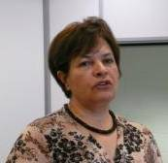
Sus-IT is short for sustainable information technologies. We want to explore how we can all remain independent, doing the things we want to do, long into our old age, with a little helping hand from new technologies. We want to know what that helping hand should do, and how it can – or can’t - help. The research project is funded by the New Dynamics of Ageing programme and led by Professor Leela Damodaran at Loughborough University.

Latest research news:

Who are you and who are you calling old?
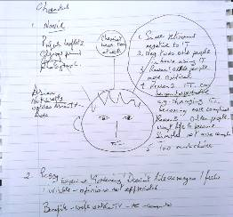
By 2020, 25% of the EU's population will be over 65. Who is this older population? One of the first steps in our research is to find out more about who you are, starting with people who are over 50. Three people joined in a session with our research team at Nottingham Trent University to help us make the publicity leaflet and the questionnaire better. The participants created a picture story to represent another real person to help describe what life is like when you are older. As a result of the comments made at the meeting we have prepared a much reduced version of the leaflet and reduced the number of questions in the questionnaire. Thank-you for reminding us that ‘less is more’.

Who is who and what is what?
Learning and playing
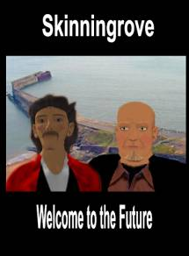
Leonie Ramondt (Anglia Ruskin University) will be exploring how new technologies bring people together to learn and share information.
In a previous project in Skinningrove in North Yorkshire, Steve Thompson our community technology specialist, helped the Skinningrove community to redesign their local community jetty using the virtual world Second Life. He was able to create a picture of what the new seaside jetty would look like – and then make an image of the Mayor so that he could ‘fly’ over it! Steve will be using that experience to help explore ways to learn that are fun and effective. Also in the learning project are Mark Shelbourn (Nottingham Trent University) and Jatinder Sandhu (Nottingham Trent University)

What is Second Life?
a) What you do after you retire
b) A TV drama
c) A virtual world

Correct answer is c) Second life is a virtual world where people can meet and socialise online in a space or place. It is more than just watching a video but if you are online have a look at the video of the Mayor of Skinningrove at http://www.ecol.org.uk/?p=207. The difference is that if you are using Second Life you get to move around and can talk to other people who are there.

A little bit of help just when you need it?
Everyone is different and we change over time, how can we get computers – including those hidden ones in ticket machines and cash machines to recognise when we need a little bit of help. What differences are important and stop us from doing the things we want, and what might just makes us feel better?
The design and development team at Loughborough includes Colin Machin, who has extensive experience of working with vision-impaired people, Matthew Tylee Atkinson, who is vision- and mobility-impaired and also works on making computer games accessible to blind gamers and Karen Li, who is adept in the technical side of things and has taught many older people how to use computers. Our man in Dundee, David Sloan, is an internationally-recognised researcher in how to improve the accessibility of systems such as the world wide web.

Keeping your mind active
Can computers play a part in keeping your mind active? Can it slow down memory loss, reduce anxiety, make life feel better? There is some evidence that keeping mentally active will help against the development of dementia. Dementia is a severe disease with memory problems that impact on all activities of daily life. The most common form of dementia, Alzheimer's disease, is characterized by a slow and gradual decline in function.

Eef Hogervorst is a psychologist from Loughborough University who wants to know if people think that computers or other technology could help prevent dementia and what sort of technology they would like.

Playing in a sandpit?
When children play in a sandpit they can be really creative in digging and building and using their imagination to create stories about their play. The term sandpit is used metaphorically to create a safe, creative place for people to explore and experiment, and to come up with new ideas and ways of doing things. David Frohlich will be working with Sarah Woods (both from Surrey University) and Amr Ahmed (Lincoln University) to create opportunities for imaginative play

Listening to you
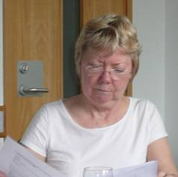
People are the most important part of our research. Nobody ever seems to think they are old. Does it matter if you are 50 or 80? Does it matter more how old you feel, look or act? Are you a valued in your community or are you ignored because your hair has gone grey (or missing)? Do you hold the family history or are you one of an increasing number living alone? The fact that more people are living longer is a cause for celebration – it is also a new phenomenon. In our research we aim to give older people a voice and to listen to what you want for your future and the new generation of older people. Irene Hardill with Jatinder Sandhu (Nottingham Trent University), Suzette Keith (Middlesex University) and Lorna Gibson (Dundee University).

Talking to each other
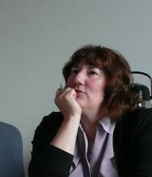
Sus-IT is a large project with researchers at many different universities. One of the activities of the project is to make sure we all learn to talk to each other and work together successfully. This activity is headed by Leela Damodaran and Wendy Olphert from Loughborough University, with Hannah Beardon who specialises in techniques to help people talk to each other.

News from Digital Britain
Martha Lane Fox who co-founded LastMinute.com was appointed as Digital Inclusion Champion as part of the government initiative for Digital Britain. Martha will be working with a Task Force of experts from a range of related organisations. Her task force of 10 experts includes Tom Wright, Age Concern and Help the Aged and Helen Milner of UK Online

Contacts

Principal Investigator
Professor Leela Damodaran
Lead Co-Investigator
Wendy Olphert
For further information and enquiries
Please contact the project administrator
Mrs Nga Nguyen
Email: n.nguyen@lboro.ac.uk
Tel: (+44) 01509 635653

Department of Information Science
Loughborough University
Loughborough
Leicestershire LE11 3TU
Web: http://nda.lboro.ac.uk

Newsletter Editor
Suzette Keith
School of Engineering and Information Sciences
Middlesex University
The Burroughs
Hendon
London NW4 4BT
Email: s.keith@mdx.ac.uk
Tel: 020 8411 5098

Next newsletter
Please email me copy for the next newsletter for Winter 2009 by
1st November 2009

Sus-IT is funded by

